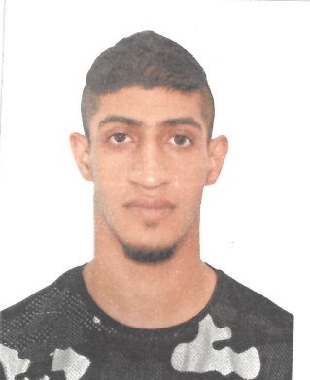

**CURRICULUM VITAE**

**ALI JAMEEL A.NABI MANSOOR SALMAN ALTOBLANI**

**m**anama, Kingdom of Bahrain

Contact : 36900121

|  |  |
| --- | --- |
|  | |
| ***Professional Objective:*** |

To strive for a challenging job in a progressive organization, where I can contribute and build my professional career along with the growth of organization and to give the best of my qualification, experience and abilities.

|  |
| --- |
| ***Personal Information:*** |

Citizenship : Bahraini

Sex : Male

Marital Status : Single

Date of Birth : 09/5/1998

CPR No : 980502080

Driving license : 980502080

First Issue : 08/06/2016

Expiry Date : 07/06/2021

Languages Known : English, Arabic, Hindi

|  |
| --- |
| ***Educational Qualifications:*** |

* NAIM SCHOOL

|  |
| --- |
| ***Computer Knowledge:*** |

* Office Packages : MS-Office

(Word, Excel & PowerPoint)

|  |
| --- |
| ***Work Experience:*** |

* King Fahad Custome 1 Year

|  |
| --- |
| ***Personal Strength:*** |

* Energetic
* Co-operative and conscientious
* Quick learner
* Hard worker
* Self-Confident

|  |
| --- |
| ***Declaration:*** |

I hereby declare that the above mentioned are true to the best of my knowledge and Belief.

**ALI JAMEEL A.NABI MANSOOR SALMAN ALTOBLANI**